Clinical Training Program in
Imago Relationship Therapy
For psychotherapists, psychologists, psychiatrists, marriage and
family therapists seeking expertise in couples’ therapy
OPQ accredited for 105 hours

2020 in MONTREAL, QC, CANADA
offered by Sophie Slade, Ph.D., www.sophieslade.com
Certified Imago Relationship Therapist, Workshop Presenter & Clinical Instructor

What you can expect from this one-year training in couples therapy
- A deep theoretical understanding of couple relationships which serves as a map to guide your interventions - why we pick the partners we do, why we have the conflicts we have, and what to do to help move couples into the joy that is our essence.
- Practice in developing skill in facilitating couples, holding them gently and firmly in new ways of connecting through the Imago dialogue processes, deepening their empathic connection, and empowering them to heal their relationship hurts.
- A sense that couple therapy can be fun and enlivening for you and your clients
- The experience of belonging to a worldwide community of Imago practitioners supporting each other and continuing to develop Imago theory and practice.
- All your OPQ Continuing Education credits for 5 years in one in-depth training experience.
- A personal growth experience that will quite possibly impact your own personal and professional relationships, your way of working with all your clients and your way of being in the world.

Comments from some of Sophie’s former trainees: “This was a very amazing training and I feel I have grown enormously both professionally and in my personal relationship.” D. Winterbourne. “Sophie is truly an exceptional instructor. I had so many “aha” moments both on a personal and professional level, that I’d highly recommend the training to anyone.” S. Weyeneth; “It is so valuable and exciting to see Sophie working the seamless flow and be gifted by receiving her feedback. Not only does Sophie come across as very intelligent and competent but also as a warm, loving and safe guide” A.Schaal. “A very valuable training, I’ve learnt so much. I’ve loved it. It’s so positive. The theory of Imago really makes sense and seems to go with the work. You see you do make a difference very quickly with clients”. N.Mason.

Imago Relationship Therapy is a research-supported, systematic theory of relationship therapy developed by Harville Hendrix, Ph.D., and Helen LaKelly Hunt, Ph.D., authors of Getting the Love you Want: a Guide for Couples. IRT powerfully synthesizes major aspects of depth psychology, object relations, systems theory, humanistic-existential theory and brain research into a comprehensive approach to working with relationships.
https://www.youtube.com/watch?v=tlRy1w5CrZU
The complete Imago Training Program for certification as an Imago Relationship Therapist consists of three modules of 4 days each plus 9 hours of on-line study, followed by 6 months of clinical consultation to a required level of competence for certification. The modules must be attended in sequence.

Dates: Days 1-2: April 2-3, 2020 - Communicating for Connection
Days 3-4: April 4-5, 2020 - Deepening the Emotional Connection
Days 5-8: June 4-7, 2020 - Through Conflict to Connection
Days 9-12: October 1-4, 2020 - Amplifying the Positive

Hours: 9 a.m. to 6 p.m.
Location: Centre Imago - Montréal, 5202 rue de Verdun, Montreal, QC H4H 1K1
Cost: $3,500. Discounts if you have already attended Introduction to Imago : Days 1-2 or Days 1-4 in person or on-line. (This is not the “Getting the Love You Want” workshop).
Non-therapist partners are very welcome to audit the course for $1,600.
Pre-requisites: Attendance at a “Getting the Love You Want” workshop. Membership in a professional organization such as OPQ with requirements for training and ethics that allows you to do psychotherapy with couples. An Educator Track is available for Thérapeutes en Relation d’Aide, Relationship Therapists and Coaches.

IMAGO CLINICAL TRAINING

REGISTRATION FORM for CLINICAL and EDUCATOR TRACK TRAINEES

I would like to register for the Imago Clinical Training in Montreal .

Name:
Address:

Tel.. personal ______Tel. prof: _______

Email:
I have attended an Imago couples workshop/or I will be attending an Imago couples workshop
Location: ____________________ Date:_________________ Presenter :

I am a member of OPQ______ Other regulating body with standards of training, supervision and ethics for

the practice of psychotherapy. ______ Which? ___________________________________________________

I wish to participate on the Educator Track ______ My credentials _____________________________________

REGISTRATION FORM for NON-THERAPIST PARTNERS

I would like to register to audit the Imago Clinical Training in Montreal as a non-therapist partner.

Name:
Address:
Town: County: Postal code:
Country:
Tel.: _________________________________________

Email:
I have attended an Imago couples workshop or couples therapy/or I will be attending an Imago couples workshop
Location: ____________________ Date:_________________ Presenter :

Occupation:

I hereby agree that I will not in any way use this training to work as a couples’ therapist or present myself as being trained in couples therapy or as being certified or accredited by Imago. I acknowledge that I will be participating for my personal benefit.

I have read and accept the above conditions regarding Imago Clinical Training. I take full responsibility for my participation in the Imago Clinical Training.

Name __________________________________________________

Date _____________________________ Signature _________________________________________

Please register early to ensure your place. This is a small group training.

For more information and to register contact Sophie Slade at slade.imago@bellnet.ca

Important information regarding payments (please keep). Payment plans available on request.
Costs: $3,500 for accreditation as an Imago Relationship Therapist or Imago Educator. OPQ accreditations RP02082-17 (14 hours) + RP02874-19 (91 hours) for therapists.
Meals and accommodations are not included. Snacks and beverages will be provided.
Non-therapist partners are welcome to attend. Cost: $1,600 for non-therapist partners.
Fees payable to Sophie Slade by bank transfer at time time of registration.
These fees do not include the cost of clinical supervision or a fee of $265 for the certification process payable at completion of training.
Clinical consultation for a minimum of once monthly for 6 months or equivalent, to required standard of competence in Imago therapy is payable to consultant. May be group or individual consultation.
Bank information for payments from within Canada: Payments to be made to Sophie Slade’s account by e-transfer to slade.imago@bellnet.ca
For information on paying in US dollars please contact Sophie Slade.
Cancellation Policy

A registration fee of $350 ($160) is non-refundable. It can be deferred to a later training. If your application for the full training is not accepted your payments will be refunded.
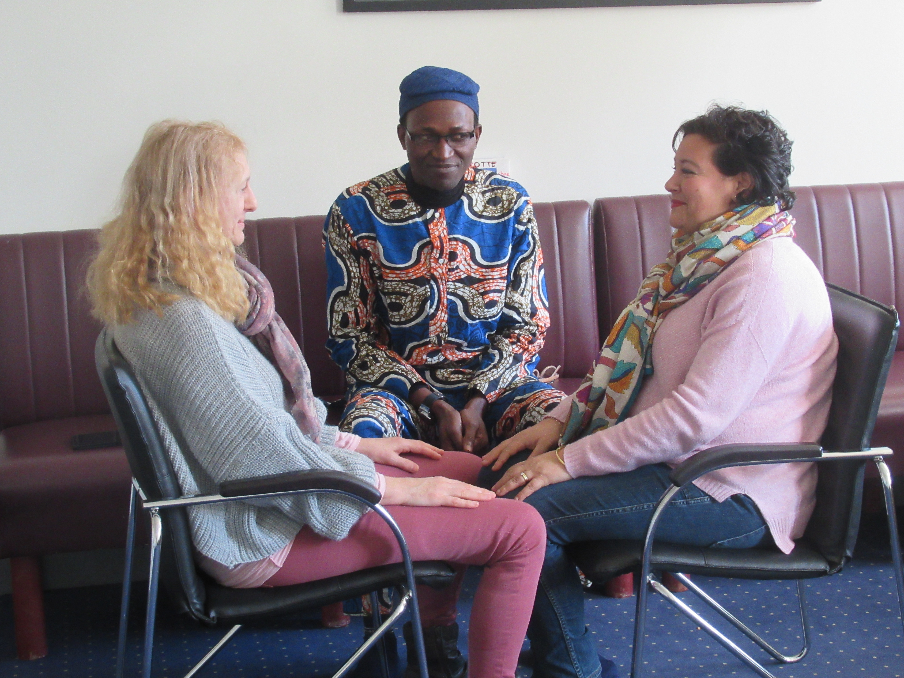

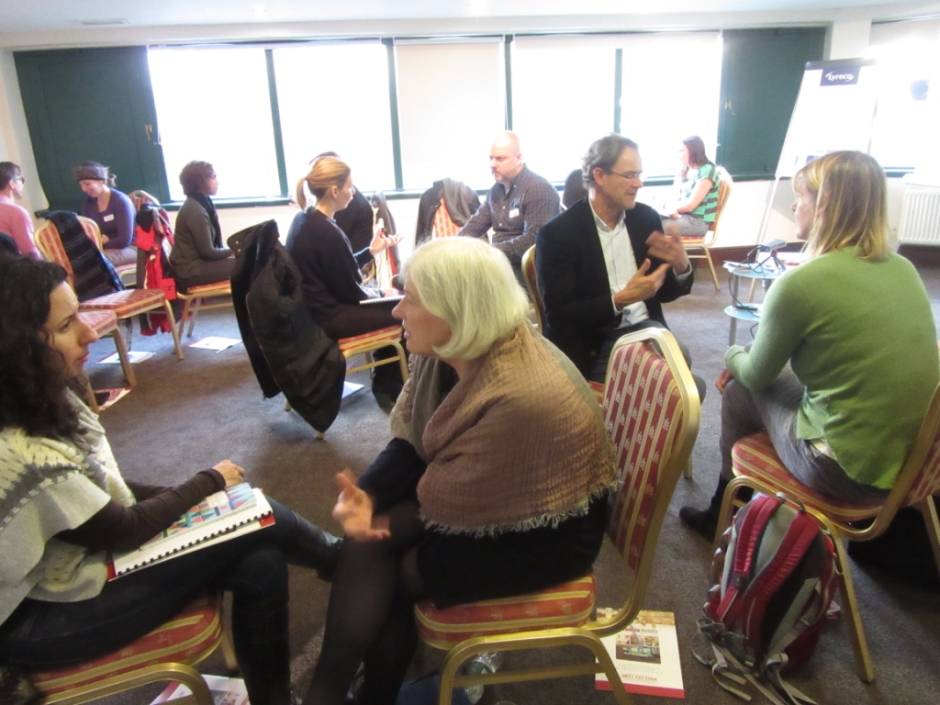
Imago Trainings

REGISTRATION FORM, MONTREAL, CANADA – 2019-20
Imago Clinical Training

Welcome. We are very happy you are interested in registering for the Imago Clinical Training and helping couples to experience the safety and connection they seek.
Name of Instructor: Sophie Slade, Ph.D. Senior Imago Clinical Instructor
Location: Centre Imago - Montréal, 5202 rue de Verdun, Montréal, QC H4H 1K1
Dates: Days 1-2: April 2-3, 2020 - Communicating for Connection
Days 3-4: April 4-5, 2020 - Deepening the Emotional Connection
Days 5-8: June 4-7, 2020 - Through Conflict to Connection
Days 9-12: October 1-4, 2020 - Amplifying the Positive

Hours: 9 a.m. to 6 p.m.
(Please note dates and hours. Participants are expected to attend all the training hours. Additional costs might be incurred if trainees have to make up missed hours. Please make travel plans accordingly.)

To Register:

- Please complete and sign the form above and return it to Sophie Slade at slade.imago@bellnet.ca or you can register on-line at www.sophieslade.com.

- Pay $350 by bank e-transfer to: slade.imago@bellnet.ca. (security answer - Imago). For payments from outside of Canada, please contact Sophie Slade

3) Send all supporting documentation listed below by email to slade.imago@bellnet.ca

Clinical Track - Admission Requirements for Participation
- Have a diploma or certification recognized in the area of psychotherapy or psychology.
- Belong to a recognized professional organization such as OPQ with standards of ethics, training and supervision
- Have experience working with couples or a desire to work with couples
- Be willing to do personal work to grow yourself as a therapist and a person.
- Have attended an Imago couples workshop, presented by a certified Imago Workshop Presenter, before the start of the training. If this is not possible it is required before certification. May attend with friend or colleague or be paired with another Imago trainee if unable to attend with a partner. (if this is not possible then during the training is accepted). Workshops are offered around the world, in Montreal in English by Sophie Slade. For dates see www.sophieslade.com.

Educator Track - Admission Requirements for Participation
Each application is evaluated by the Instructor individually on the basis of documents submitted. If you do not meet all the above criteria but believe that you are qualified, please include a letter specifying your qualifications and why you believe you are suitable for the training, as well as submitting the appropriate documentation.
- Have training to work with couples in a modality other than psychotherapy.
- Belong to a professional organization with standards of professional ethics, training and supervision.
- Have experience working with couples.
- Have participated in personal growth work and be willing to continue to do personal work during the training.
- Have attended an Imago couples workshop, see above.

Non-therapist partners are welcome to attend the training with their therapist partner. They will be expected to participate fully in the training for the benefit of their own relationship. They will not be trained to facilitate couples. For more information see below.

To complete your registration, please send the following supporting documentation as soon as possible to slade.imago@bellnet.ca or Dr. S. Slade, 5202 rue de Verdun, Montreal, QC H4H 1K1
- The completed and signed registration form - see above
- Your curriculum vitae
- Documentation that supports your right to practice psychotherapy in your country (e.g. OPQ license) or to work in some other modality with couples
- Copy of your diploma or degree
- The list of professional associations that you belong to
- A copy of your professional liability insurance policy
It is essential that you send these documents before the start of the training.

Requirements during the training to become a certified Imago Relationship Therapist
- Complete all 12 days of the Imago Clinical Training + 9 hours of on-line training. Any hours missed due to particular circumstances must be made up, possibly at additional expense to the trainee.
- Participate actively in small group and dyad work, including personal growth work.
- Read the required material.
- Bring video recordings of extracts of your Imago work with couples for supervision.
- Participate in supervision with an Imago Faculty member or Clinical Consultant, either once a month individually for six months, or some agreed upon equivalent such as group supervision, during which the trainee will present at least 4 videos of their clinical work with couples.
- After the 15 days of training, participate as an assistant at an Imago couples workshop, presented by a certified Imago Workshop Presenter.
- Submit two written reports of 1 - 2 pages outlining your experience of integrating Imago personally and professionally, with particular reference to your own growth edges, as identified during the training. To be submitted 3 months and 6 months after completion of the 15 days of training.
- Present to your clinical instructor a final video of your work with a couple of an acceptable standard for certification and participate in an exit interview.
- Pay all fees in full by the designated dates. Payment plans can be arranged individually with Dr. Slade.
- Sign a contract with IITI (Imago International Training Institute)

Certification as an Imago Relationship Therapist is awarded when all the requirements have been satisfactorily completed and accepted by the Instructor. You can then become a full member of the global Imago community.

Non-therapist partners - Admission Requirements for Auditing the Imago Clinical Training
We like to keep couples together and on the same page so we welcome non-therapist partners to attend the clinical training and do the personal work with their therapist partners, if they desire. This is not a training for non-therapists to become a couples therapists, however many participants find it is very useful in their own field of expertise.
- Have attended an Imago couples workshop, presented by a certified Imago Workshop Presenter, before the start of the training or attended Imago therapy with their partner. (if this is not possible then during the training is accepted). Workshops are offered around the world, in Montreal in English by Sophie Slade. For dates see website.
- Be willing to do personal work and interact with other participants.
Each application is evaluated by the Instructor individually.
To complete your registration, please send the following supporting documentation as soon as possible to slade.imago@bellnet.ca or Dr. S. Slade, 5202 rue de Verdun, Montreal, QC H4H 1K1
- The registration form completed and signed
- Your curriculum vitae
- A letter outlining who you are and why you want to attend the training
- $160 by bank transfer to Dr. Sophie Slade (see above)

Requirements during the training
- Participate actively in small group and dyad work, including personal growth work.
- Pay all fees in full by the designated dates. Payment plans can be arranged individually with Dr. Slade.
- If you wish to receive a certificate as an Imago Educator you will be required to complete a project.

Please now complete the REGISTRATION FORM ON THE NEXT PAGE and send it to Sophie Slade at slade.imago@bellnet.ca and make the payment for the registration fee.

Sophie Slade, Ph.D., Centre Imago – Montréal
5202 rue de Verdun, Montréal, QC H4H 1K1, Canada
Slade.imago@bellnet.ca; +1 514 766-5502; www.sophieslade.com

Sophie Slade

