a transformative weekend for couples
developed by Harville Hendrix, Ph.D., & Helen LaKelly Hunt, Ph.D.
presented by Sophie Slade Ph.D.
On November 7th and 8th, 2020
(Saturday 9am-7pm and Sunday 9am-6pm)

at Grange Wellington Hotel, 71 Vincent Square,London SW1P 2PA

”A good relationship keeps us happier and healthier”
Robert Waldinger, TEDxBeaconStreet “What makes a good life?”

Whether you’ve just fallen in love, are looking to restore your romance, or are in chronic conflict, this workshop is for you. During the weekend you and your partner will learn a new way to talk and listen that will help you:
- Discover each other in a new way.
- Heal each other’s deepest wounds.
- Deepen and sustain a joyful connection.
- Acquire essential information and skills to help make your relationship successful and lasting, or to figure out if you want to be together;
- Develop a fresh understanding of the “exquisite perfection of the fit” between you in areas of greatest conflict;
- Transform your conflicts into opportunities for growth and healing
- Meet the chimp and turtle who can take over your relationship
- And oh, so much more to create the relationship you want!

All personal work is done with your partner. This is an educational experience for couples, NOT group therapy. The workshop includes lectures, written exercises, live demonstrations and practice sessions between partners. You share only with your partner with the support of facilitators, if needed.

A few of the many wonderful comments from previous participants: “The most powerful experience I’ve had in my life so far! This workshop changed the way I understand myself, my partner and the ways we interact. The concepts are universal, incredibly positive and useful.” “So simple, practical and produces results. Our lives have been enriched and transformed by this process”; “Sophie has the gift of love and dedication in her way of presenting, explaining, respecting. At all times inclusive and patient”; “Sophie and David are a tangible example of Imago at work in real relationships. It was very inspiring”; “Highly recommended - I can now see that incompatibility with your partner is not necessarily a recipe for disaster, but for a successful life-long partnership”; “Having had a couple of half- hearted attempts at relationship counselling which I couldn’t buy into, the Imago approach was a ‘breath of fresh air’ and enabled me to see my partner through new, enriched eyes”; ”Extraordinary course, with exercises which changed our relationship immediately…”

Cost: £625 per couple
To register or for any queries contact: Bryan Greene at
bryan99greene@gmail.com 01275 395 215 or see www.sophieslade.com

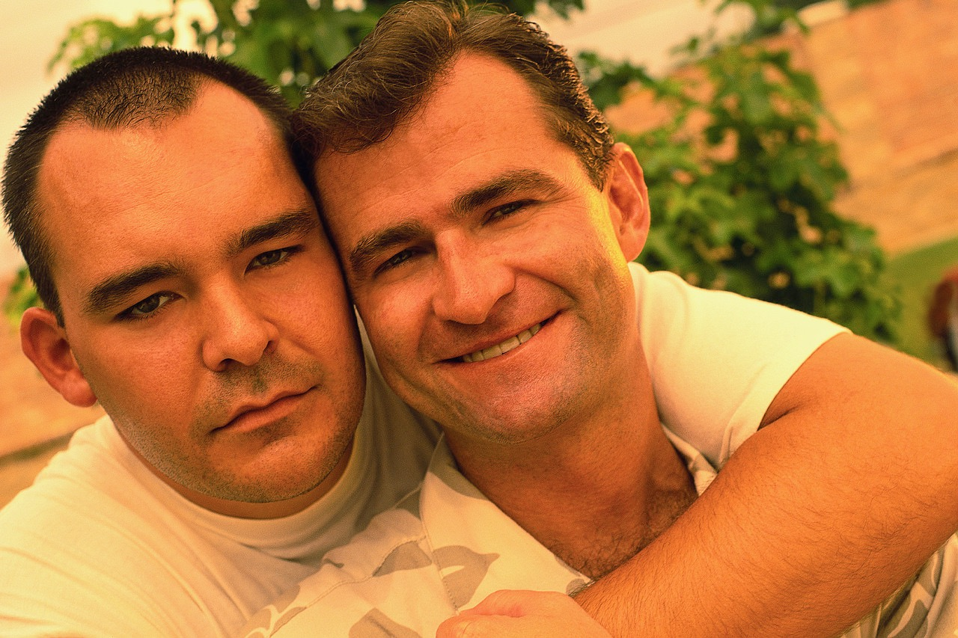
“Getting the Love You Want”

REGISTRATION FORM

Please complete and return to Bryan Greene by email bryan99greene@gmail.com

We wish to register for: “Getting the Love You Want”

Date: _______________________________________________________________

Name(s): ______________________________________________________________

Address:________________________________________________________________

Telephone:________________________________________________________________

Email : ________________________________________________________________

How we heard about the workshop: _________________________________________

Please make a bank transfer of £625 per couple to Sophie Slade’s account:
NatWest Branch sort code # 51 50 00, Account # 64038815.
Please identify your payment with your name, the month of the workshop & “Getting”, e.g. Smith Feb Getting.
For payments from outside UK: IBAN: GB28 NWBK 515000 64038815; BIC NWBK GB 2L
My address: 11 Amazon Building, New River Village, London, N8 7QE
Bank address: NatWest Southgate Branch, 12 The Broadway, Southgate, London N14 6QF

Cancellation policy. A registration fee of £75 per couple is non-refundable.
For cancellation up to one week prior to workshop, the balance of payment will be refunded. For cancellations less than one week before the workshop date no refunds will be given but attendance can be deferred to a later date with payment of £75.

Relationship skills training for curious (or desperate) couples
