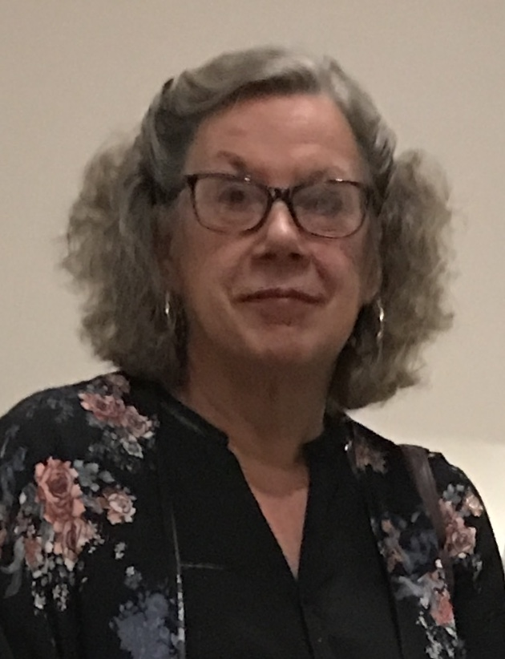
COMMUNICATING FOR CONNECTION
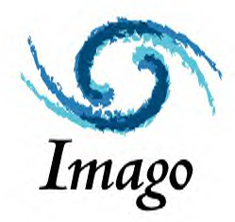
An Introduction to
Imago Relationship Therapy
Montréal, Quebec,
October 10-11, 2019, & January 8-9, 2020
OPQ Accreditation #: RP02082-17 (14 hours)

Imago Relationship Therapy, developed by Harville Hendrix, Ph.D., & Helen LaKelly Hunt, Ph.D., focuses on connection and joy. Therapists are trained to facilitate the experience of connecting between partners in intimate couple relationships. Ruptures of connection are experienced as painful. Partners then often react defensively to protect themselves against the pain which usually increases the pain, defensiveness and lack of connection, contributing to the downward spiral of disconnectedness.

The Imago Dialogue is a structured process that helps couples communicate in ways that increase the experience of safety, understanding and empathy leading to increased connecting, well-being and joy. It gives couples a new way of being in relationship to replace the old, ineffective and disruptive communication habits.

As a therapist participant you will see demonstrations of facilitation by instructor, Sophie Slade, be facilitated in the Imago Dialogue process yourself, and have opportunities to practice facilitating the Dialogue with positive feedback to help you hold couples in connection, as well as understanding the meta-theory behind the Dialogue process. You will also learn the powerful Appreciation Dialogue which can be integrated immediately into your work.

The practical skills of Dialogue and solid theoretical base are research supported.

This 2-day training may challenge the way you are in your own relationship, how you work with your couples and add to your skills in working with both couples and with individual clients.

You will take away some practical skills you can integrate immediately into your work. If you choose to continue to explore Imago by taking the full Imago Clinical Training for certification as an Imago Relationship Therapist, these two days count towards this one-year training.

Location: Centre Imago - Montréal, 5202 rue de Verdun, Montreal, QC H4H 1K1
Cost: $400
Hours: 9 a.m. to 6 p.m.
Instructor: Sophie Slade, Ph.D., Psychologist. Sophie is a Senior Clinical Instructor in Imago Relationship Therapy who offers Imago training around the world. She has been working with couples using Imago therapy since 1992 and is still as passionate today about Imago and the help it can bring to couples, as she was when she started. In 2014 she received the Harville Hendrix Award for Clinical Excellence. She is described as warm, safe and fun to train with.

To register please complete this registration form and return it to
slade.imago@bellnet.ca.

REGISTRATION FORM: Communicating for Connection - An Introduction to Imago Relationship Therapy

Dates of Training:

Name:

Address:

Email:

Phone:

Profession (psychologist, social worker, psychotherapist, psychiatrist, marriage and family therapist, etc.)

Professional Affiliation (e.g. OPQ):

How I heard about the training:

Please make payment of $400 by bank transfer to my email slade.imago@bellnet.ca, security question response - Imago

For more information about this 2-day training as well as the full Imago Clinical Training please contact Sophie Slade at slade.imago@bellnet.ca. Visit my website at www.sophieslade.com

You can purchase a video series of Sophie Slade facilitating a range of Imago dialogue processes, available at sophieslade.vhx.tv.

Sophie Slade, Ph.D.
Psychologist,
Imago Relationship Therapist, Workshop Presenter
& Senior Clinical Instructor,
www.sophieslade.com
slade.imago@bellnet.ca
+1 514 766 5502

